Feature Selection
- A feature is an attribute that has an impact on a problem or is useful for the problem, and choosing the important features for the model is known as feature selection. Each machine learning process depends on feature engineering, which mainly contains two processes; which are Feature Selection and Feature Extraction.
- The main difference between them is that feature selection is about selecting the subset of the original feature set, whereas feature extraction creates new features. Feature selection is a way of reducing the input variable for the model by using only relevant data in order to reduce over fitting in the model.
"It is a process of automatically or manually selecting the subset of most appropriate and relevant features to be used in model building."

Need for Feature Selection

- Feature selection is a critical aspect of machine learning that involves choosing the most relevant features from a dataset.
- It plays a significant role in improving model performance, reducing over fitting, and enhancing interpretability.
- Feature selection is a way of selecting the subset of the most relevant features from the original features set by removing the redundant, irrelevant, or noisy features.
Some benefits of using feature selection in machine learning:
- It helps in avoiding the curse of dimensionality.
- It helps in the simplification of the model so that it can be easily interpreted by the researchers.
- It reduces the training time.
- It reduces over fitting hence enhance the generalization.

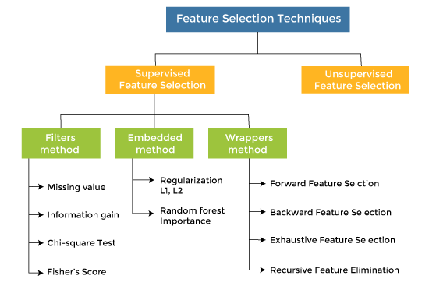

How to choose a Feature Selection Method?
The more we know the data types of variables, the easier it is to choose the appropriate statistical measure for feature selection.
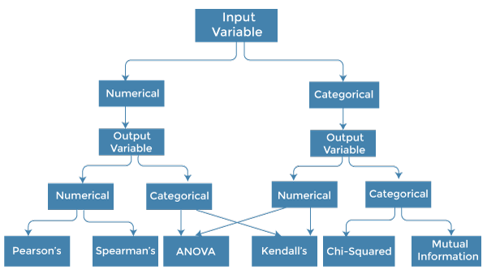

First identify the type of input and output variables. In machine learning, variables are of mainly two types:
- Numerical Variables: Variable with continuous values such as integer, float
- Categorical Variables: Variables with categorical values such as Boolean, ordinal, nominals.

Types of Feature Selection Techniques:

1. Filter Methods
Filter methods assess the relevance of features based on statistical measures based on their correlation with the target variable. Examples include chi-square test, information gain, and correlation coefficient. Features are selected based on their individual characteristics, without considering the machine learning algorithm used.

2. Wrapper Methods

Wrapper methods use a specific machine learning algorithm to evaluate feature importance. They select features based on their impact on model performance. They wrap the feature selection process around the model training and evaluate the model’s performance to determine the optimal subset of features. Wrapper method follows a greedy search approach by evaluating all the possible combinations of features against the evaluation criterion. Examples include recursive feature elimination (RFE) i.e. eliminating the feature having lowest coefficient and forward/backward stepwise selection.


3. Embedded Methods
Embedded methods incorporate feature selection into the model training process. They select features based on their contribution to the model’s predictive power. The feature selection is embedded within the algorithm, and the model selects the most relevant features during training. Example : adding a penalty to the different parameters of the machine learning model to reduce the freedom of the model and tree-based methods like Random Forests, which assign feature importance scores.
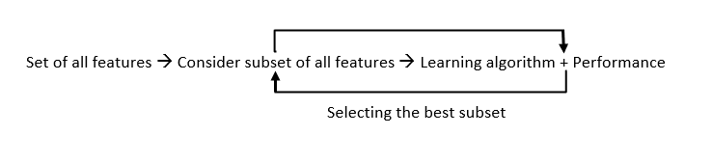

4. Hybrid Methods
Hybrid methods combine aspects of filter, wrapper, and embedded methods. They leverage the strengths of multiple techniques. Dimensionality reduction techniques, such as Principal Component Analysis (PCA) transform the original features into a lower-dimensional space while preserving important information. These methods are effective for reducing the feature space but do not explicitly select individual features.

Feature Extraction
Feature extraction is a machine learning technique that reduces the number of resources required for processing while retaining significant or relevant information. In other words, feature extraction entails constructing new features that retain the key information from the original data but in a more efficient manner transforming raw data into a set of numerical features that a computer program can easily understand and use.

When working with huge datasets, particularly in fields such as image processing, natural language processing, and signal processing, it is usual to encounter data containing multiple characteristics, many of which may be useless or redundant. Feature extraction simplifies the data, these features capture the essential characteristics of the original data, allowing for more efficient processing and analysis.

Why is Feature Extraction Important?
Feature extraction is crucial for several reasons:
- Reduced Computation Cost: The real world data is usually complex and multi-faceted. The task of feature extraction lets us to see just the vital data in the sea of the visual data. Hence, it gives simplicity to the data, thereby making the machines to handle it and process it easily.
- Improved Model Performance: Extracting and choosing key characteristics may provide information about the underlying processes that created the data hence increasing the accuracy of the model performance.
- Better Insights: Algorithms generally perform better with less features. This is because noise and extraneous information are eliminated, enabling the algorithm to concentrate on the data's most significant features.
- Overfitting Prevention: When models have too many characteristics, they might get overfitted to the training data, which means they won't generalize well to new, unknown data. Feature extraction prevents this by simplifying the model.

Different types of Techniques for Feature Extraction

Various techniques exist to extract meaningful features from different types of data:

1. Statistical Methods
Statistical methods are widely used in feature extraction to summarize and explain patterns of data. Common data attributes include:

- Mean: The average number of a dataset.
- Median: The middle number of a value when it is sorted in ascending order.
- Standard Deviation: A measure of the spread or dispersion of a sample.
- Correlation and Covariance: Measures of the linear relationship between two or more factors.
- Regression Analysis: A way to model the link between a dependent variable and one or more independent factors.
These statistical methods can be used to represent the center trend, spread, and links within a collection.

2. Dimensionality Reduction Methods for feature extraction
Dimensionality reduction is an essential stage in machine learning for feature extraction because it reduces the complexity of high-dimensional data, enhances model interpretability, and prevents the curse of dimensionality. Dimensionality reduction approaches include Principal Component Analysis (PCA), Linear Discriminant Analysis (LDA)

3. Feature Extraction Methods for Textual Data
Feature extraction for textual data allows the change of unorganized text into a numerical format that can be handled by machine learning algorithms. Textual data methods for feature extraction are important for natural language processing (NLP) tasks, common methods are:
- Bag of Words (BoW): The Bag of Words (BoW) model is a basic way for text modeling and feature extraction in NLP. It shows a written document as a multiset of its words, ignoring structure and word order, but keeping the frequency of words. This model is useful for tasks such as text classification, document matching, and text grouping. The BoW model is used in document classification, where each word is used as a feature for training the classifier.
- Term Frequency-Inverse Document Frequency (TF-IDF) : Term Frequency-Inverse Document Frequency (TF-IDF) is a feature extraction method that catches some of the major problems which are not too common in the total collection. TF-IDF is a method that measures the value of a word in a document based on its frequency in the document and its rarity across the entire collection. It is commonly used in text classification, mood analysis, and information retrieval.

Feature Selection | Feature Extraction
Selects a subset of relevant features from the original set of features. | Transforms original features into a new, more informative set.
Reduces dimensionality while keeping original features. | Reduces dimensionality by transforming data into a new space.
Methods include Filter, Wrapper and Embedded techniques. | Methods include PCA, LDA, Kernel PCA and Autoencoders.
Requires domain knowledge and feature engineering. | Can be applied to raw data without prior feature engineering.
Enhances interpretability and reduces overfitting. | Improves performance and handles nonlinear relationships.
May lose useful information if important features are removed. | May introduce redundancy and noise if extracted features are not well-defined.

